Task 2:- Design High-Fidelity Wireframes For A Mobile Application.
Quick-Bite
Mobile App Wireframing — UX Design Case Study
Sk Altamash Ali
Intern ID: THX-JUL2126-688



1. Project Overview
Quick-Bite is a mobile food-delivery app concept created to practice UX design planning end to end: identifying user needs through research, mapping a user flow, and translating that into wireframes. This version presents the concept in mid-fidelity — real photography, brand colors, and typography applied — building on the earlier low-fidelity structure to show how the same flow holds up once visual design is layered on top.

Problem Statement
Existing food delivery apps often hide delivery time and total cost until late in the ordering process, and require too many steps to complete checkout. This leads to cart abandonment and user frustration, especially for time-pressed users ordering on a break or after work.

2. User Research
Research method: short informal interviews with 5 regular food-delivery users (students and working professionals), asking about ordering frequency, pain points with existing apps, and what would make them order more often.

Key Questions Asked
- How often do you order food delivery, and from which apps?
- What frustrates you about existing delivery apps?
- What would make you order more often, or more comfortably?

Key Findings
- Users want to see estimated delivery time and total cost before browsing a restaurant's menu in depth.
- Users frequently abandon orders when checkout involves too many screens or steps.
- Users with repeat habits (students, professionals ordering the same meals) want a fast way to reorder past meals.
- Unclear delivery status after ordering ("where is my food?") is a recurring source of anxiety.

3. User Personas

Persona 1 — "Busy Student"
- Age 20, university student, orders food 3–4 times per week between classes
- Goals: fast ordering, low cost, quick reorder of favorite meals
- Frustration: too many taps required to complete checkout

Persona 2 — "Working Professional" (David)
- Age 28, orders dinner after work, occasionally orders for family
- Goals: reliable delivery time estimates, easy saved payment methods, clear order tracking
- Frustration: unclear ETA and poor visibility into order status after placing it
Note: the Home and Order Tracking screens in this version are personalized for David, illustrating how the Working Professional persona's needs (personal greeting, saved payment, live tracking) are reflected directly in the interface.

4. User Flow
The core "happy path" flow below shows how a user moves from opening the app to receiving their order, and maps directly onto the seven screens in Section 5.
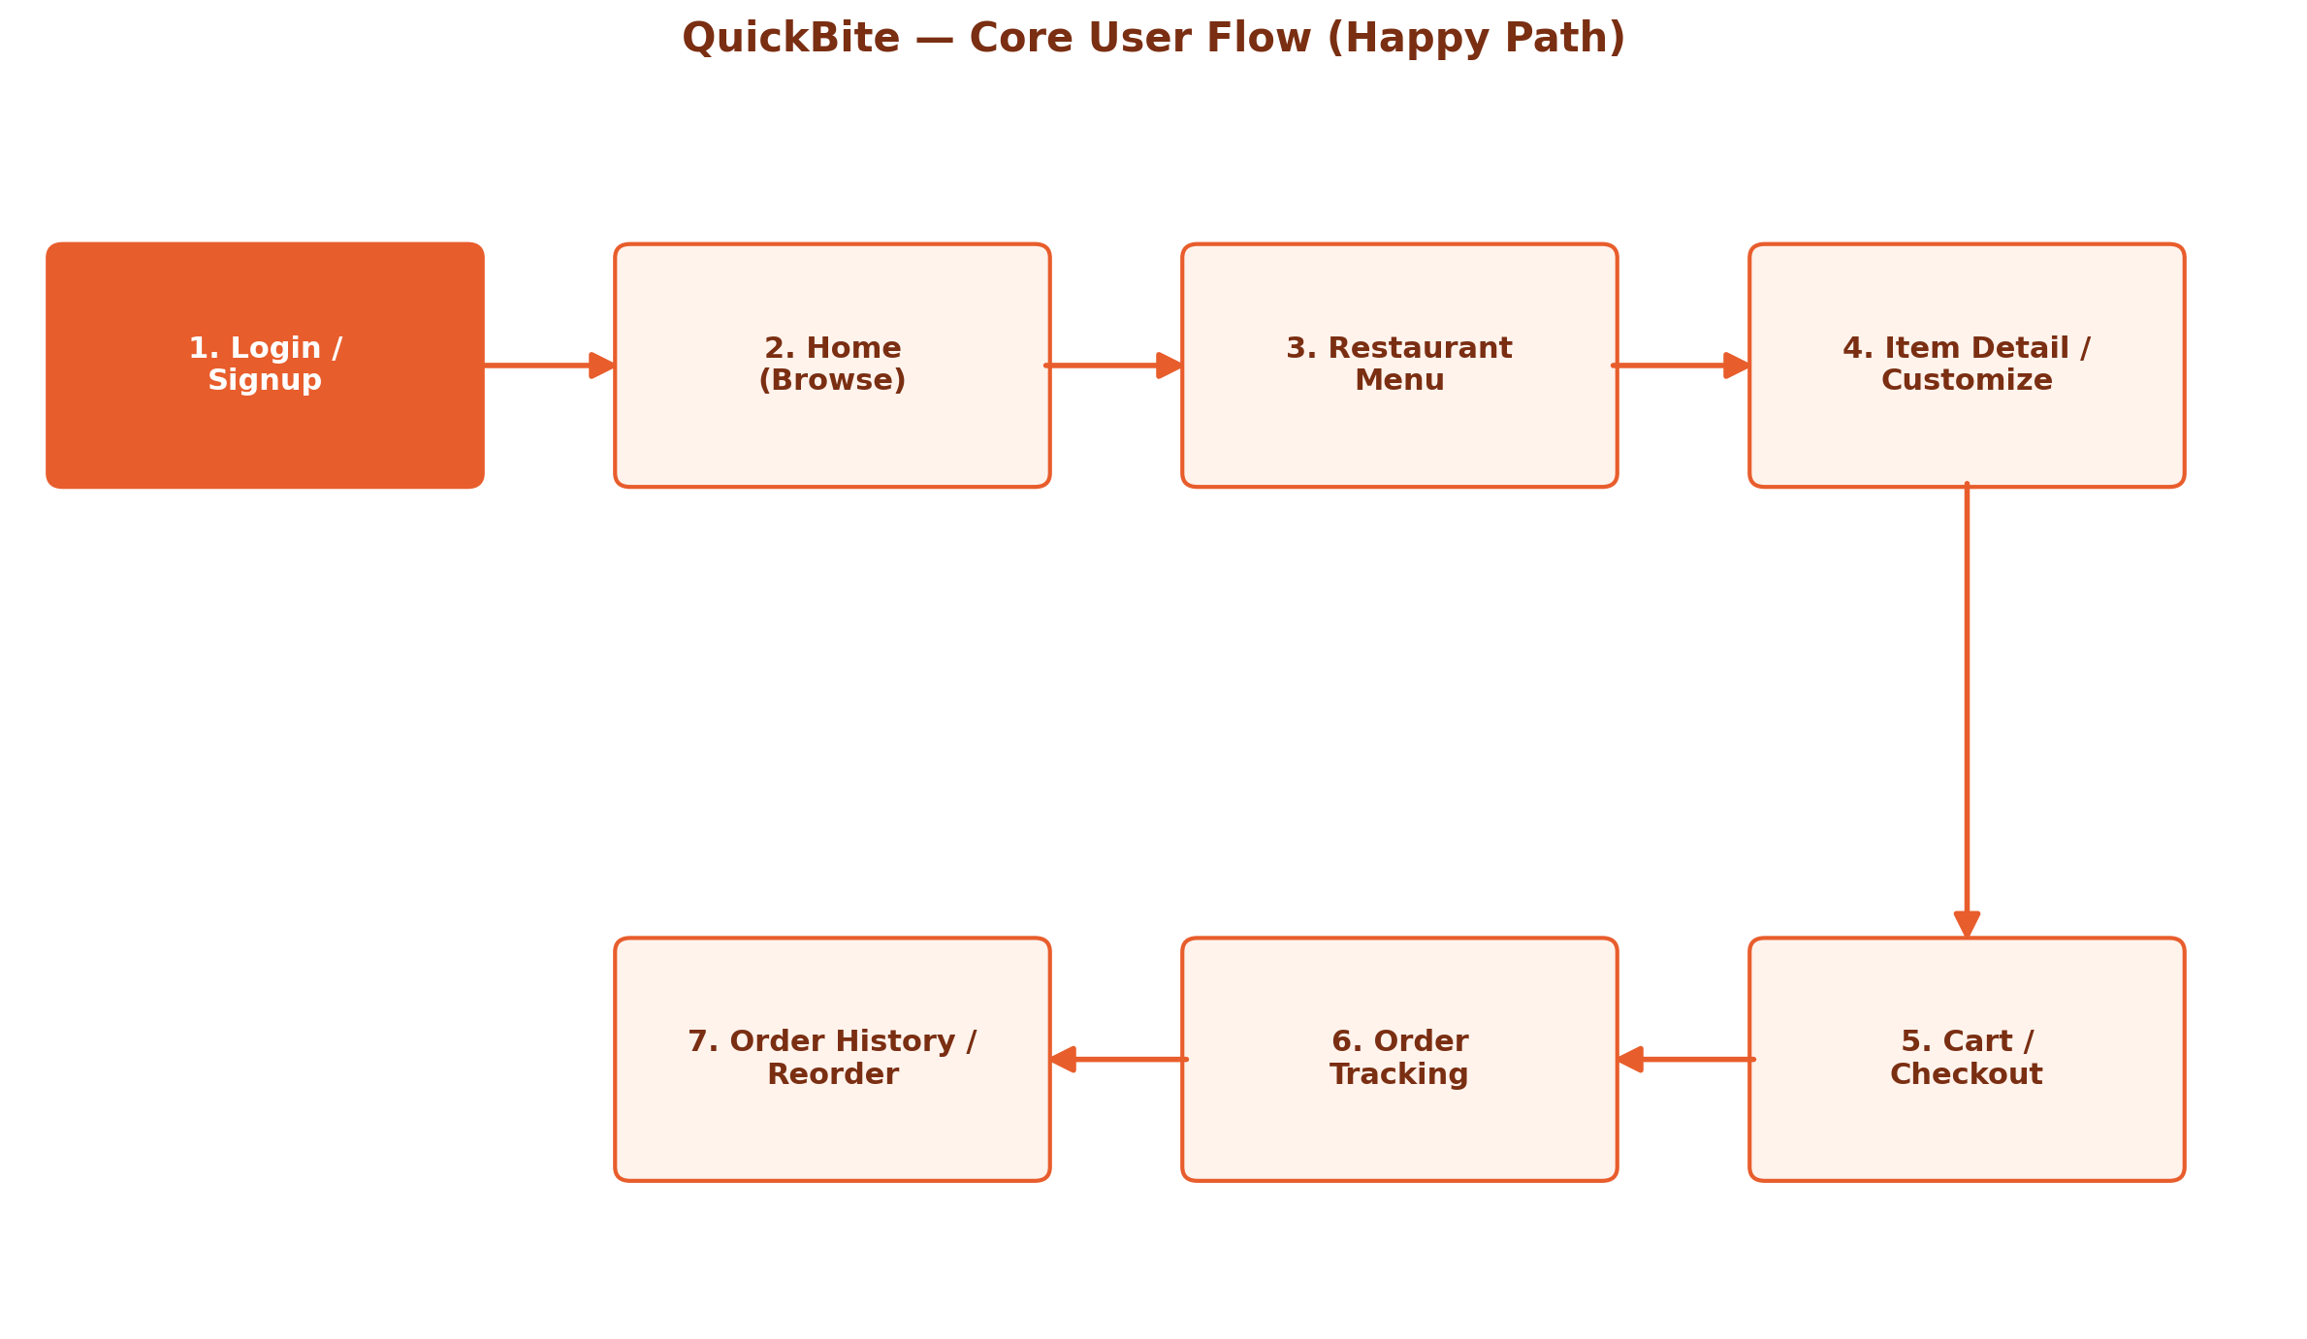
Flow: Login/Signup → Home (browse restaurants) → Restaurant Menu → Item Detail (customize & add to cart) → Cart/Checkout → Order Tracking → Order History (reorder).

5. Wireframes
This set of screens builds on the original low-fidelity wireframes, now rendered with the Quick-Bite brand — warm orange/red palette, real food photography, and finished typography — while keeping the same screen count and flow validated at the low-fidelity stage. Each screen ties back to a research finding or persona need, noted below.

2. Home Screen
Personalized greeting, search bar, category filters, and a promo banner drive engagement. Restaurant cards show rating, delivery time, and fee up front — directly answering the research finding that users want cost/time visible before committing.
1. Login / Signup
Branded entry screen with email/password login plus Google and Apple social sign-in for faster onboarding. Reduces friction identified in research: users don't want a long signup form before they can browse.

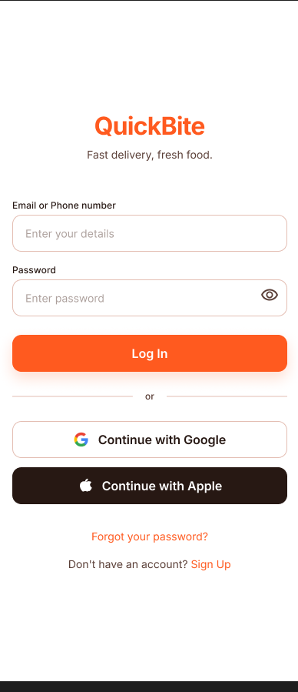
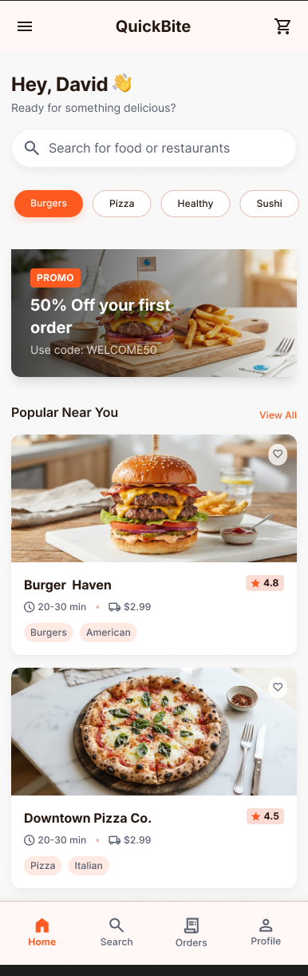

4. Item Detail / Customize
Full customization flow — patty choice, add-ons, and special instructions — with a persistent Add to Cart bar. Addresses the 'too many taps' checkout frustration by keeping all options on one screen.
3. Restaurant Menu
Restaurant hero image with rating/time/fee header, menu items grouped by category, and quick-add (+) buttons so users can build an order without leaving the menu view.

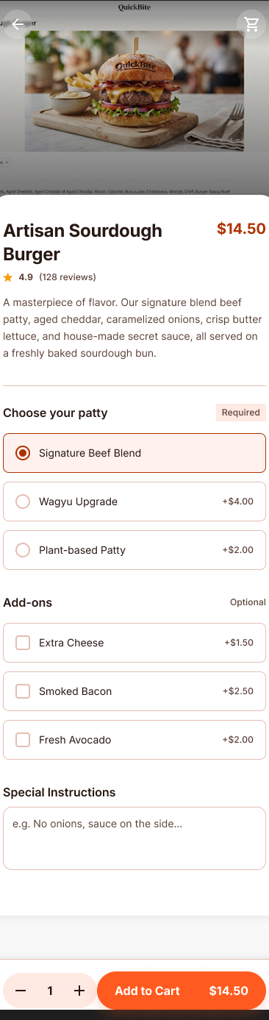
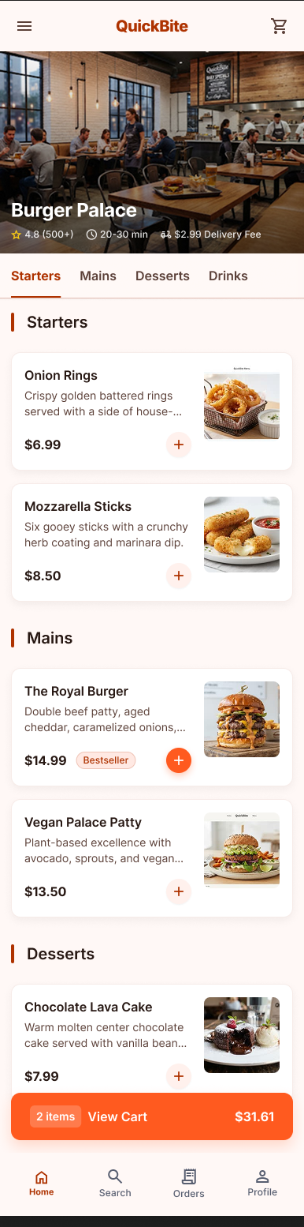

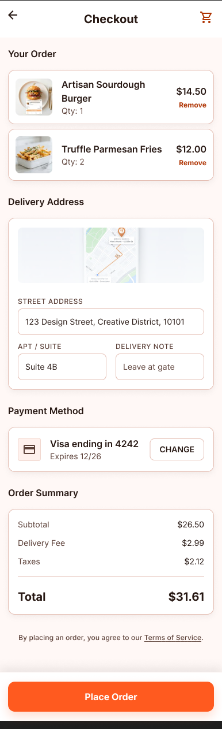
6. Order Tracking
Live map placeholder, delivery partner contact, and a status stepper (Confirmed → Preparing → In Transit → Delivered) — giving users the real-time ETA visibility they said they lacked in other apps.
5. Cart / Checkout
Order summary, delivery address, payment method, and full price breakdown consolidated on a single screen to minimize checkout steps.

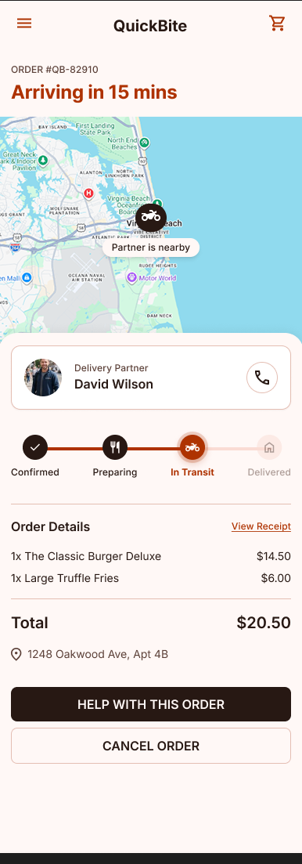

7. Order History
Searchable list of past orders with status tags and a one-tap Reorder button, directly serving the 'Busy Student' persona's need for fast repeat ordering.

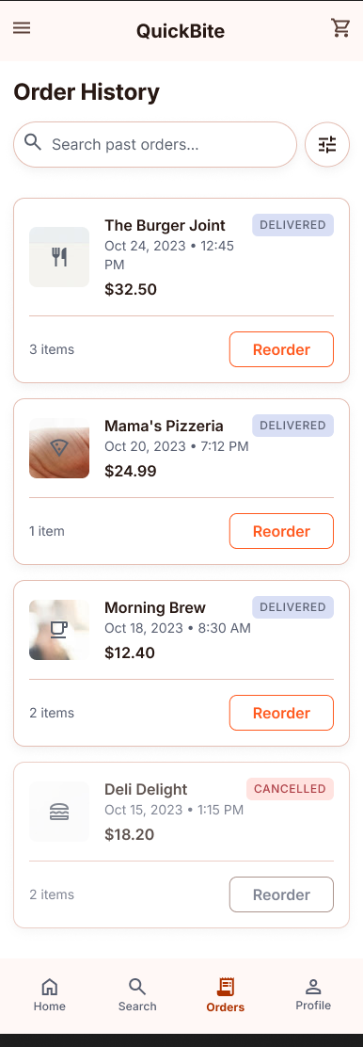

6. Design Thinking Process

Empathize
Conducted informal interviews with regular food-delivery users to surface real frustrations (Section 2), and distilled them into two representative personas (Section 3) to keep design decisions grounded in actual user needs rather than assumptions.

Define
Problem statement: users abandon orders or feel anxious post-order because existing apps hide cost/time information early and provide poor order-status visibility. The design goal became: surface time/cost early, minimize checkout steps, and give clear real-time order status.

Ideate
Mapped the simplest possible path a user could take from opening the app to receiving food (Section 4), and identified exactly seven screens needed to support that path — deliberately avoiding extra screens that would add navigation overhead.

Prototype
Started with grayscale, placeholder-only low-fidelity wireframes to validate structure and flow without visual distraction. Once the flow was confirmed, the same seven screens were rebuilt in mid-fidelity (Section 5) with the Quick-Bite brand identity — color, photography, and typography — to test how the structure holds up with real content.

